1. Install TASM 64 bit Assembler

2. Double click on shortcut generated on desktop

3. Following screen will be displayed as follows

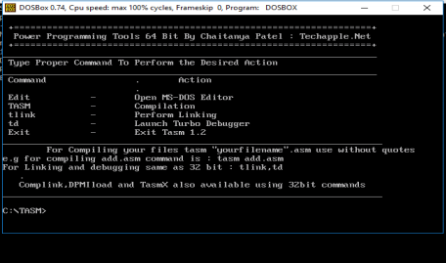

4. Type C:\TASM> EDIT

5. Following screen will be displayed

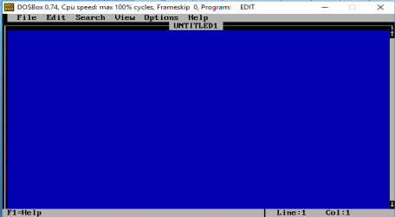

6. Go in File and save the file name as: **ADD.ASM** and press OK

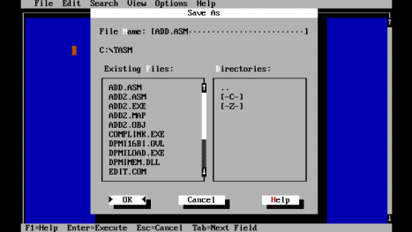

7. Following Screen will be displayed

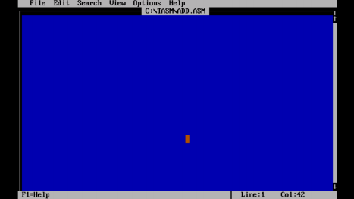

8. Now type the following program

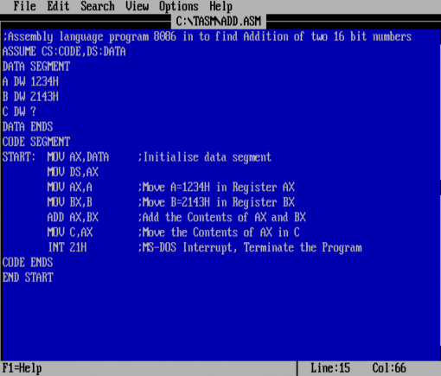

9. Now save you program from File Menu

10. Now click on Exit in File Menu

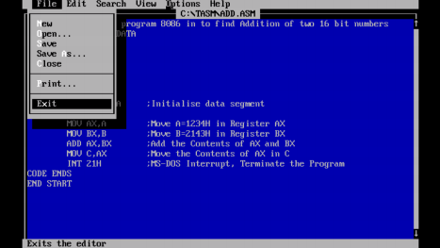

11. Following screen will be displayed

12. Now type the following command

13. C:\TASM> TASM ADD.ASM press enter

14. C:\TASM> TLINK ADD.OBJ press enter

15. C:\TASM>TD ADD press enter

16. Following screen will be displayed

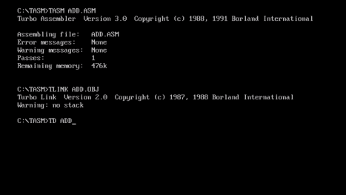

17. Now following screen will be displayed

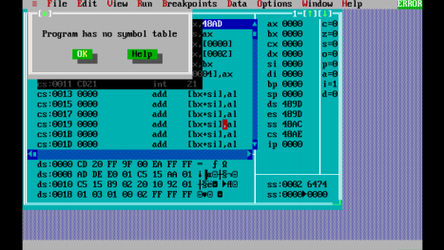18. Now press ESC button on Keyboard

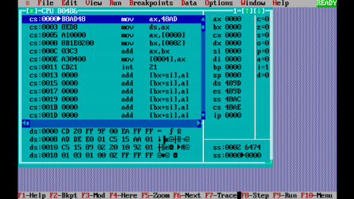19. Press F7 till INT 21H instruction is reached

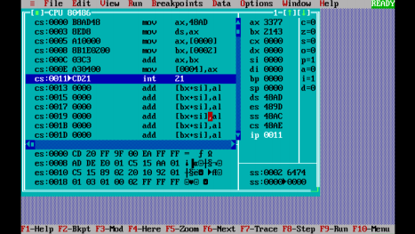

20. Once INT 21 is reached press (1) prt sc (print screen) button of key board (2) then Ctrl + C (3) then open MS Word File and(4) then press Ctrl+V

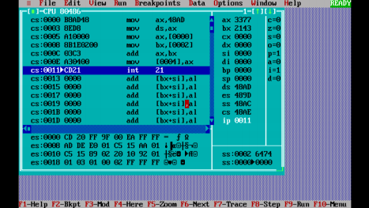

21. The Output of Addition can be seen in Register : ax on the right side.

22. To the extreme right one can see the flag affected during the generation of Output.

**Flowchart Symbols**

|  |  |  |
| --- | --- | --- |
| **Symbol** | **Name** | **Function** |
|  | Start / End | An oval represents a start or end point |
|  | Arrow | A line is a connector that shows relationships between the representative shapes |
|  | Input / Output | A parallelogram represents input or output |
|  | Process | A Rectangle represents a process |
|  | Decision | A diamond indicates a decision. Indicates a question or branch in the process flow. Typically, a Decision flowchart shape is used when there are 2 options (Yes/No, No/No-Go, etc.) |
|  | Manual Input | Represents the manual input of data into a computer, usually through a keyboard |
|  | Connector | In flowcharts, this symbol is typically small and is used as a Connector to show a jump from one point in the process flow to another. Connectors are usually labeled with capital letters (A, B, AA) to show matching jump points. |
|  | Off-Page  Connector | Off-Page Connector shows continuation of a process flowchart onto another page. |
|  | Display | Indicates a process step where information is displayed to a person (e.g., PC user, machine operator). |

**STEPS OF WRITING ASSEMBLY LANGUAGE PROGRAMME IN PRACTICAL RECORD**

|  |  |
| --- | --- |
| Program No: 1  **Program: Write an Assembly language program in 8086 to find Addition of two 16 bit numbers.**  **Flow Chart:**  Start  Initialise  A=1234H,  B=2143H  C=A+B  Display C  Stop | Program No: 1 |
|  |
| **Program: Write an Assembly language** |
| **program in 8086 to find Addition of two 16** |
| **bit numbers.** |
|  |
| **Algorithm:-** |
| Step 1:- Start |
| Step 2:- Initialise A 1234 h, B 2143h |
| Step 3:- Perform |
| (i) C 1234h + 2143 h |
| Step 4: Display C |
| Step 5: Stop |
|  |
|  |
|  |
|  |
|  |
|  |
|  |
|  |
|  |
|  |
|  |
|  |
|  |
|  |
|  |
|  |
|  |

|  |  |
| --- | --- |
| **Output:-**  **16 Bit Multiplication**  **A=2122H**  **B=0002H**  **C=4244D / 1094H**  **8 Bit Multiplication**  **P= 0005H**  **Q=0003H**  **R=0015D / 000FH** | **Program:-** |
| ;Assembly language program in 8086 to find Addition of |
| two 16 bit numbers |
| ASSUME CS:CODE,DS:DATA |
| DATA SEGMENT |
| A DW 1234H |
| B DW 2143H |
| C DW ? |
| DATA ENDS |
| CODE SEGMENT |
| START: MOV AX,DATA ;Initialise data segment |
| MOV DS,AX |
| MOV AX,A ;Move A=1234H in Register AX |
| MOV BX,B ;Move B=2143H in Register BX |
| ADD AX,BX ;Add the Contents of AX and BX |
| MOV C,AX ;Move the Contents of AX in C |
| INT 21H ;MS-DOS Interrupt, Terminate the Program |
| CODE ENDS |
| END START |
|  |
|  |
| **Output:-** |
| **16 bit addition** |
| **A=1234H** |
| **B=2143H** |
| **C=3377H** |